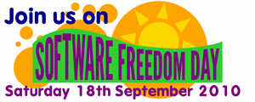

Saturday 18th September 2 PM

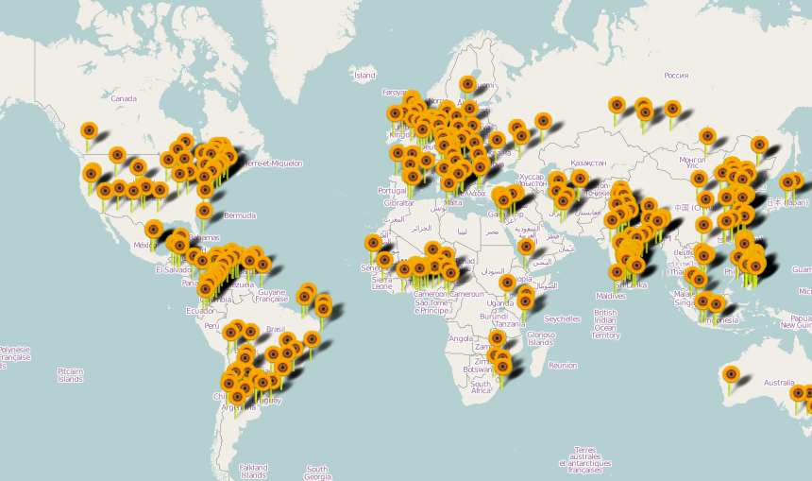
Software Freedom Day is every-where. Each year thousands of teams organize Software Free-dom Day in different countries and cities.

This year fortiss/Munich participates!

Please join us from 2 PM at:
fortiss
Guerickestr. 25
80805 München
Public transport: U6 / Nordfriedhof

Talks will be held in 2 tracks:
- Introduction to free Software
- Expert knowledge in free software


fortiss
Guerickestr. 25 / 80805 München
Contact: Amir H. Moin (moin@amirhmoin.com)

